Grade 12 - Computer Science
Worksheet 3 – Chapter14

Question 1:
Expand the following abbreviations:
- HTTP
- ARPANET.
Question 2:
What is protocol? Which protocol is used to copy a file from/to a remote server?
Question 3:
What is protocol? Which protocol is used to search information from Internet using an Internet browser
Question 4:
What is the advantage of using SWITCH over HUB?
Question 5:
What is difference between star topology and bus topology of network? Delhi 2009; 2012C
Question 6:
What is modem?
Question 7:
A company wants to form a network on their five computers to a server within the company premises. Represent star and ring topologies diagrammatically for this network.
Question 8:
Trine Tech Corporation (TTC) is a professional consultancy company. The company is planning to set up their new offices in Inaia with its hub at Hyderabad. As a network adviser, you have to understand their requirement and suggest them the best available solutions. Their queries are mentioned as (i) to (iv) below.
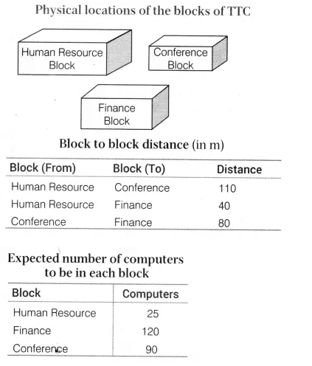
- Which will be the most appropriate block, where TTC should plan to install their server?
- Draw a block to block cable layout to connect all the buildings in the most appropriate manner for efficient communication.
- What will be the best possible connectivity out of the following, you will suggest to connect the new set up of offices in Bengalore with its London based office.
  - Satellite Link
  - Infrared
  - Ethernet
- Which of the following device will be suggested by you to connect each computer in each of the buildings?
  - Switch
  - Modem
  - Gateway
Question 9:
Granuda consultants are setting up a secured network for their office campus at Fa rida bad for their day-to-day office and web based activities. They are planning to have connectivity between 3 buildings and the head office situated in Kolkata. Answer the questions (i) to (iv) after going through the building positions in the campus and other details, which are given below.
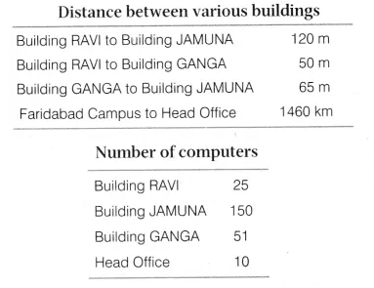
- Suggest the most suitable place (i.e. block) to house the server of this organisation. Also, give a reason to justify your suggested location.
- Suggest a cable layout of connections between the building inside the campus.
- Suggest the placement of the following devices with justification:
(a) Switch
(b) Repeater
- The organisation is planning to provide a high speed link with its head office situated in the Kolkata using a wired connection. Which of the following cable will be most suitable for this job?
(a) Optical fibre
(b) Co-axial cable
(c) Ethernet cable
Question 10:
Freshminds University of India is starting its first campus in Ana Nagar of South India with its centre admission office in Kolkata. The university has three major blocks comprising of Office block, Science block and Commerce block is in 5 km area campus.
As a network expert, you need to suggest the network plan as per (i) to (iv) to the authorities keeping in mind the distance and other given parameters.
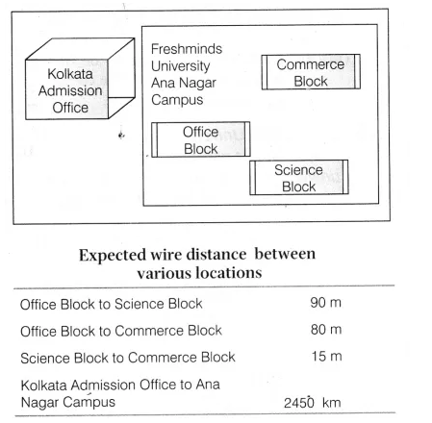
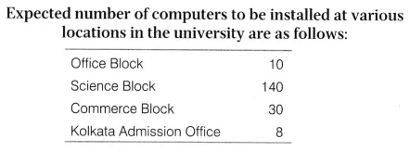
- Suggest the authorities, the cable layout amongst various blocks inside university campus for connecting the blocks.
- Suggest the most suitable place (i.e. block) to house the server for this university with a suitable reason.
- Suggest an efficient device form the following to be installed in each of the block to connect all the computers,
(a) Modem (b) Switch (c) Gateway
- Suggest the most suitable (very high speed) service to provide data connectivity between admission office located in Kolkata and the campus located in Ana Nagar form the following options:
  - Telephone line
  - Fixedline dial-up connection
  - Co-axial cable network
  - GSM
  - Leased line
  - Satellite connection.

